Note: the last version of this document is available on http://quantumtheory.physik.unibas.ch/shalaev/cv.html

Curriculum Vitae
Oleg Shalaev
Availability: 04/16/2014.
Contact information:
Phone: 573-268-2108
email: chalaev@gmail.com
skype ID: chalaev
http://quantumtheory.physik.unibas.ch/shalaev/

Personality
I am not an outstanding programmer and/or system administrator – many people would beat me in that. However, it is not easy to find someone who can solve a problem from the very beginning until the end better than me, namely: (a) formalize the problem, (b) invent the algorithm(s), (c) program the code and test it, and (d) write the report and make a presentation.
Next, I believe that there is no knowledge which I am unable to understand. I do not trust statements which I can not demonstrate myself, no matter how influential is the person who makes them. In particular, I do not trust books, and from time to time find errors in them.
Ready to relocate: I have done it 5 times during the last 15 years, for a total distance of 9920
miles, and more or less got used to it.

Employment history
- 04/15/2013-present: post-doctoral researcher at the University of Rochester (NY).
Supervisor: Hanan Dery <hanan.dery@rochester.edu>
525 Computer Studies Bldg., P.O. BOX 270231, 14627-0231 Rochester NY, USA.
Phone: 585-275-3870.
- 08/16/2012-03/29/2013: post-doctoral researcher at the CSUN.
Supervisor: Nicholas Kioussis <nick.kioussis@csun.edu>
Live Oak Hall, CSUN, 18111 Nordhoff Street, Northridge, CA 91330, USA.
Phone: 818-677-7733. Ran away from him to NY.
- 12/01/2008-08/15/2012: post-doctoral researcher at the University of Missouri.
Supervisor: Giovanni Vignale <vignaleg@missouri.edu>
223 Physics Bldg., University of Missouri, Columbia, MO 65211-7010, USA.
Phone: 573-882-3670.
- 11/01/2003-11/30/2008: post-doctoral researcher at the University of Basel (Switzerland).
Supervisor: Daniel Loss <daniel.loss@unibas.ch>
University of Basel, Klingelbergstrasse 82, CH-4056 Basel, Switzerland.
Phone: +41-61-267-3750.

Education
- 1998 M.S. in Physics with Distinction, St. Petersburg Technical University: “Transport properties of HTSC: evidence of T_{c} -inhomogeneity”.
- 2003 Ph.D. in Physics at SISSA: “Nonequilibrium persistent currents in mesoscopic disordered systems”.

General skills
- Work style: many people are proud to be experts in software XXX and computer language YYY; many job advertisements require such proficiency. From my point of view software proficiency is somewhat secondary: I always learned the necessary software and computer languages fast when I needed them. For me the hardest part of a problem is to develop an appropriate algorithm; its programming is just a routine. When I work alone, I have a freedom of choosing the optimal (free) software which is the most convenient for the particular problem. Sometimes within the one problem I use completely different software systems which interact with each other (for example, maxima, C++ and gnuplot).
- Eager to learn: during the last three years I learned several topics in physics: (i) inverse scattering theory, (ii) quantum relaxation, and (iii) group theory (see my physics CV). Somewhat less important for my work was the knowledge of linux, SQL, LISP, C++, maxima, perl which I also learned myself. Finally, certain things I learn just because an opportunity comes, even if they appear to be useless at the moment. For example, I learned Italian and German because I lived in Italy and Switzerland, and no one has ever payed me for being able to speak these languages.
- Good in calculations: Experienced in doing analytical (by hand and using CAS) and numerical (C++ with LAPACK and QUADPACK libraries) calculations.
- Creative, algorithm developer: As a scientist I often do the things which have never been done before, or, in other words, I love innovations. I like to invent my own, new approaches to problems; one could check the validity of this last statement by looking on my articles
(see http://arxiv.org/find/cond-mat/1/au:+Chalaev_O/0/1/0/all/0/1), where I utilize several very different physical/mathematical techniques, enumerated in my physics CV (see the next section).
- Good in mathematics and numerical methods: In my University I had great luck with the mathematics teacher. In total I passed 8 exams on linear algebra, complex analysis, topological and metric spaces, manifolds, general theory of integrals (including Lebesgue measure), and probability theory based on Kolmogorov axioms. On every examination I had to demonstrate several (randomly chosen from the course) theorems (sometimes – only one if the proof was really long) without the help of books, notes and friends. Much of this knowledge is sleeping, but can be woken up fast: e.g., now I have to remember grounds of differential geometry (curved spaces, connections, Christoffel symbols – see http://quantumtheory.physik.unibas.ch/shalaev/geometry.pdf) and I do it fast even though I have never used differential geometry during the last 18 years.
We also had a very decent course on numerical methods: linear algebra, interpolation, integration, differential equations. All the methods were derived analytically with estimates of speed and accuracy.

Physics background
My physics expertize is described by the following PACS codes:
02.30.Zz, 02.40.-k, 61.50.Ah, 71.20.Mq, 71.20.Nr, 71.70.Ej, 72.70.+m, 73.23.-b, 73.23.Ra.
You might want to take a look on my articles
(see http://arxiv.org/find/cond-mat/1/au:+Chalaev_O/0/1/0/all/0/1)
and/or download the CV where I advertise my physics skills
(see http://quantumtheory.physik.unibas.ch/shalaev/cv.pdf).

Programing skills
- I learn computer languages fast.
- GNU/Linux: very advanced (12 years of experience). Abandoned Windows in 1999, see https://linuxcounter.net/user/310541.html
- Large data sets: had experience in dealing with about 90.000.000 files; for that I had to recompile the linux kernel with the Reiserfs4 support.
- SQL: PostgreSQL – used it for personal needs: wrote a perl-script which accumulates data for all NYSE listings on my PC using free Yahoo-finance web service. This summer (06/25/2012 and 06/29/2012) I have passed two SQL tests which made me self-confident enough to claim that I am quite good in it (at least with Postgre SQL).
- html – very basic (without java and php), just wrote my personal web site,
see http://quantumtheory.physik.unibas.ch/shalaev/
- CAS: maxima – very advanced user (wrote in total 267300 lines and 15016877 symbols of code), Mathematica – was a very advanced user before I have abandoned it 6 years ago. However, in the end of May I had to rewrite an (approx. one-page) maxima program in Mathematica and realized that I recover my Mathematica experience fast.
- Python: The Python test which I did 06/29/2012 demonstrated me that Python is very similar to maxima (see above), so I passed the test quickly despite the absence of the previous Python experience.
- C++: good in scientific programming (LAPACK, multithreading with OpenMP), see an example at http://quantumtheory.physik.unibas.ch/shalaev/kp.tar.bz2
- bash, sed, awk, emacs – advanced level; perl – wrote several middle-basic level scripts (in total 4152 lines and 144293 symbols of code).
- LaTeX – very advanced level (this CV has been initially written in LaTeX and then converted into .doc format).
- Cluster computation: openMP + openMPI + ganglia.

Other skills and general life experience
Hobbies: linux, German, OSM and table tennis.
I lived in Russia, Italy, Switzerland, USA; I met many people of different (sometimes – exotic) cultural backgrounds / nationalities. Apart from English, I speak/read/write Russian and Italian fluently. I also fluently speak German (B1 certificate from Goethe Institut), but make mistakes in declensions.
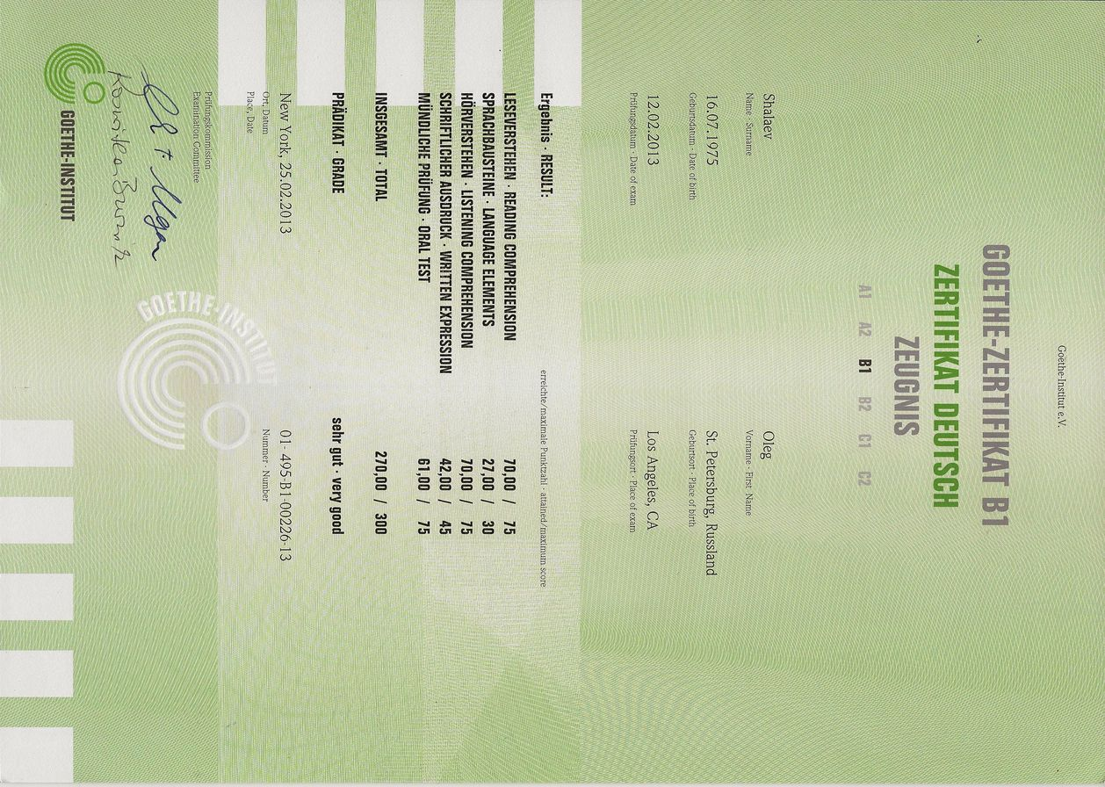

Sometimes I have a feeling of being top professional in programming; this happens, for example, when I see recruiting websites which are unable to distinguish a “physicist” from “physician” or “physical therapy” ☺.
This is the reason why I am puzzled by many job advertisements which pay so much attention to programming skills.
Before I stopped using Mathematica, I wrote a sophisticated program for manipulating Feynmann diagrams. Then there was a software upgrade in the University of Basel, and I discovered that (i) my program does not work in the new Mathematica version, (ii) I need several weeks in order to correct that, and (iii) it is impossible to get the old version back. For me this was the last straw (I knew before that Mathematica sometimes makes errors in integration and Taylor expansion), and I decided to invest my time in learning similar free software (maxima).

